Hands-on 4: Packages, Modules, and Testing

1. Prerequisites
- Terminal Access: Open your VS Code terminal.
- Environment Check: Ensure you are in a clean folder for this module.

2. Why are we doing this?
Professional software isn't just one long file. It is broken into small, manageable pieces called packages. Furthermore, Go provides a powerful "toolchain" (like go fmt and go test) that automates code styling and verification. Learning this prevents "spaghetti code" and ensures your logic actually works via Unit Testing.

3. Objective
- Organize code into custom packages.
- Understand the go.mod file and how it manages your project.
- Master the Go CLI tools (fmt, vet, test).
- Mini-Project: Create a math utility package and write unit tests to verify its logic.

4. Steps To Follow

Step 1: Initialize the Module
Go modules are the foundation of Go projects. Open your terminal and run:
mkdir go-project-pro
cd go-project-pro
go mod init go-project-pro

What happened? A go.mod file was created. This file tracks your project name and the version of Go you are using.

Step 2: Create a Custom Package
In Go, folders equal packages. Let's create a package for math logic.
- Create a folder named mathutils.
- Inside that folder, create a file named calculator.go.
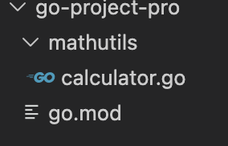
// Inside mathutils/calculator.go
package mathutils
// Function name MUST start with Uppercase to be "Exported" (public)
func Add(a, b int) int {
return a + b
}
func Multiply(a, b int) int {
return a * b
}

Step 3: Import and Use Your Package
Now, create a main.go file in the root folder (outside the mathutils folder).
// Inside main.go
package main
import (
"fmt"
"go-project-pro/mathutils" // Path: [Module Name]/[Folder Name]
)
func main() {
sum := mathutils.Add(10, 5)
prod := mathutils.Multiply(10, 5)
fmt.Printf("Sum: %d, Product: %d\n", sum, prod)
}

Run command:
go run main.go

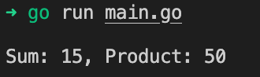

5. Mini-Project: Unit Testing
Testing is built into Go's DNA. You don't need external libraries. We will write a test for our Add function.
Create a file named mathutils/calculator_test.go (The _test.go suffix is mandatory).
package mathutils
import "testing"
func TestAdd(t *testing.T) {
// Define input and expected output
got := Add(2, 3)
want := 5
if got != want {
// If the result is wrong, tell the test runner why
t.Errorf("Add(2, 3) = %d; want %d", got, want)
}
}
func TestMultiply(t *testing.T) {
got := Multiply(4, 5)
want := 20
if got != want {
t.Errorf("Multiply(4, 5) = %d; want %d", got, want)
}
}
How to run your tests:
In the terminal, run:
go test ./... -v

(The -v flag stands for "verbose," showing you exactly which tests passed).
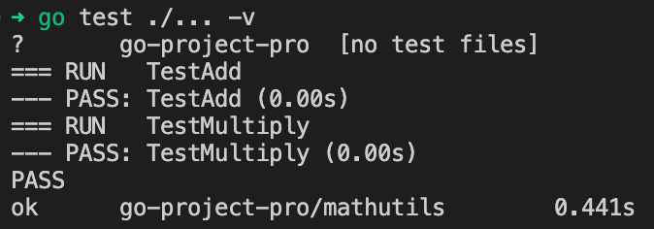

6. Checklist of Accomplishments
- [ ] Module Mastery: Initialized a project with go mod init.
- [ ] Encapsulation: Created a sub-package and exported functions (Uppercase name).
- [ ] Tooling: Cleaned code using go fmt and checked for errors with go vet.
- [ ] Unit Testing: Wrote and executed tests using the testing package.
- [ ] Verification: Confirmed 100% pass rate in the terminal.

7. Conclusion
You’ve just transitioned from "writing code" to "engineering software." By splitting your code into packages, you make it reusable and clean. By using go test, you’ve created a safety net that ensures your logic stays correct even as your project grows. This is the exact workflow used by professional Go teams worldwide.

Congrats!
Your project is organized, formatted, and fully tested. You have mastered the Go Toolchain!

